V5 BLUEPRINT
Autonomous Freight
Operating System
CEO Vision + CTO Architecture + Economics + HITL + Commercial Strategy + Compliance
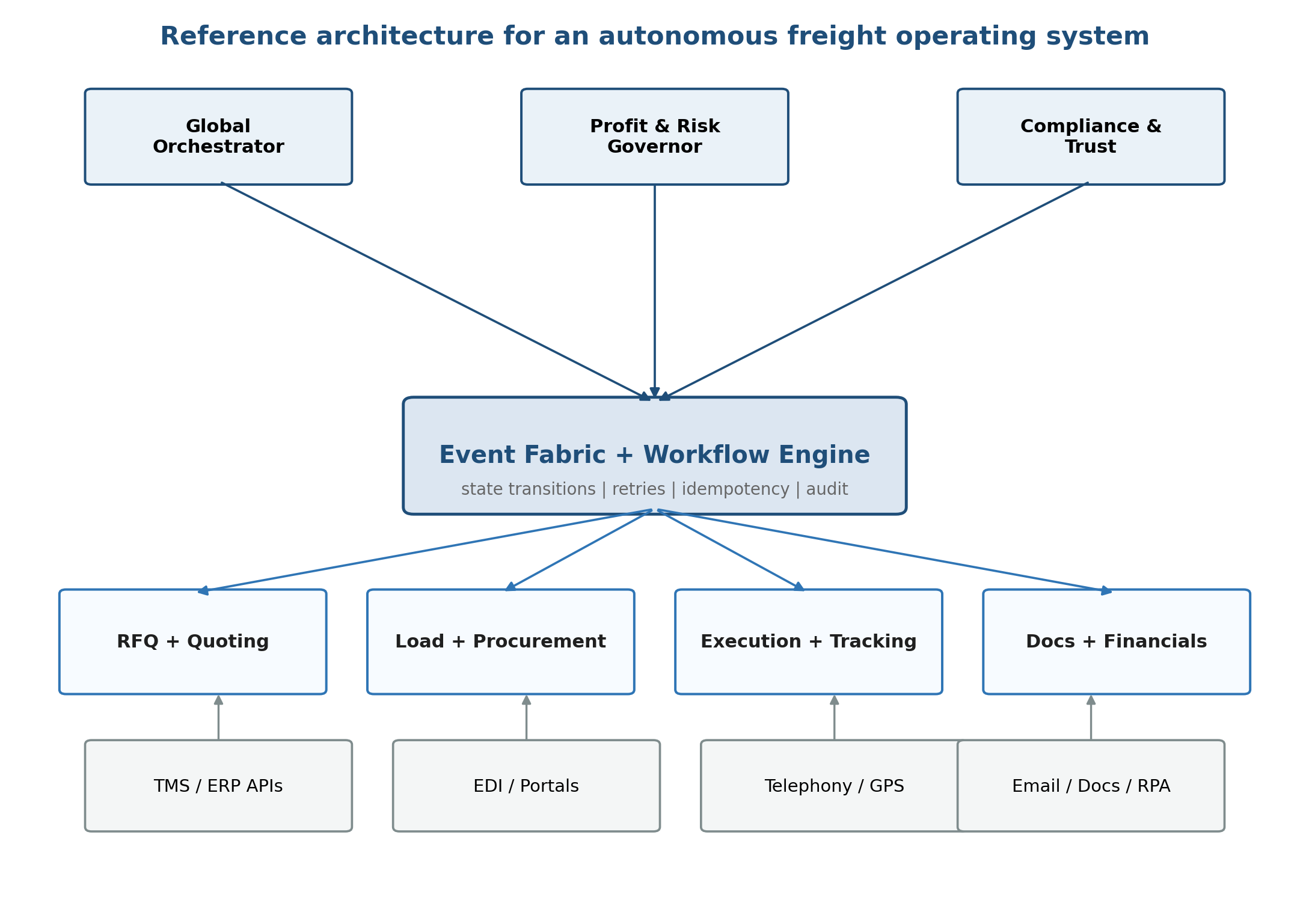
Purpose: one document that is fundable for investors, usable by operators,
concrete enough for early engineering execution, and complete enough for commercial deployment.

April 2026 • CONFIDENTIAL

1. Executive Thesis
The company is not building another transportation management system. It is building an autonomous operating layer that sits above existing TMSs and turns freight brokerage into an event-driven economic control system.
In the legacy model, work is organized around people pushing information across inboxes, portals, spreadsheets, and accounting queues. In the target model, every shipment is a stateful object that moves from RFQ to settlement through explicit transitions, specialized AI agents, and human governance at defined decision boundaries.
The strategic result is not just labor reduction. The larger outcome is better economic control: faster response times upstream, cleaner execution in the middle, and fewer billing, dispute, and settlement leaks downstream.
V5 addition: The endgame is not an assisted brokerage. It is a headless freight operating platform that can be integrated into any logistics workflow as the zero-audit logistics nervous system. Every phase described in this document is a step toward that north star.

What Success Looks Like
Dimension | Legacy Brokerage | Autonomous Model
Operating model | Humans execute every routine step | Agents execute routine path; humans govern exceptions
Scalability | Headcount rises with load count | Headcount rises with exception volume
Economic control | Margin drift appears late | Risk and margin are governed in-line
Auditability | Knowledge lives in people and inboxes | Decisions, evidence, and state changes are replayable
Revenue potential | Capacity limited by team size | Platform enables more loads, more revenue per employee

2. Canonical Lifecycle
The company spine is the RFQ-to-cash lifecycle. This is the main abstraction investors, operators, and engineers should all share.
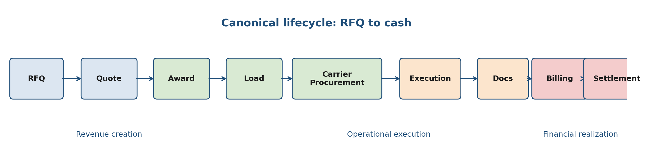
Figure 1. Canonical lifecycle from inbound demand to financial realization.

Lifecycle Design Rules
- Upstream decisions must preserve downstream financial truth. A quote that cannot be supported operationally or financially is a defective object from birth.
- The system must distinguish operational completion from billing eligibility. Delivered is not the same thing as invoice-ready.
- Customer-side AR and carrier-side AP are separate but synchronized flows. They share the same shipment context but not the same decision logic.
V5 addition: The canonical lifecycle now extends through invoice, settlement, dispute resolution, and cash realization. See Section 12 for the complete invoice-to-cash lifecycle that closes the loop from delivery to money.

3. Reference Architecture
The architecture is designed around a workflow engine and event fabric rather than around a monolithic application service.
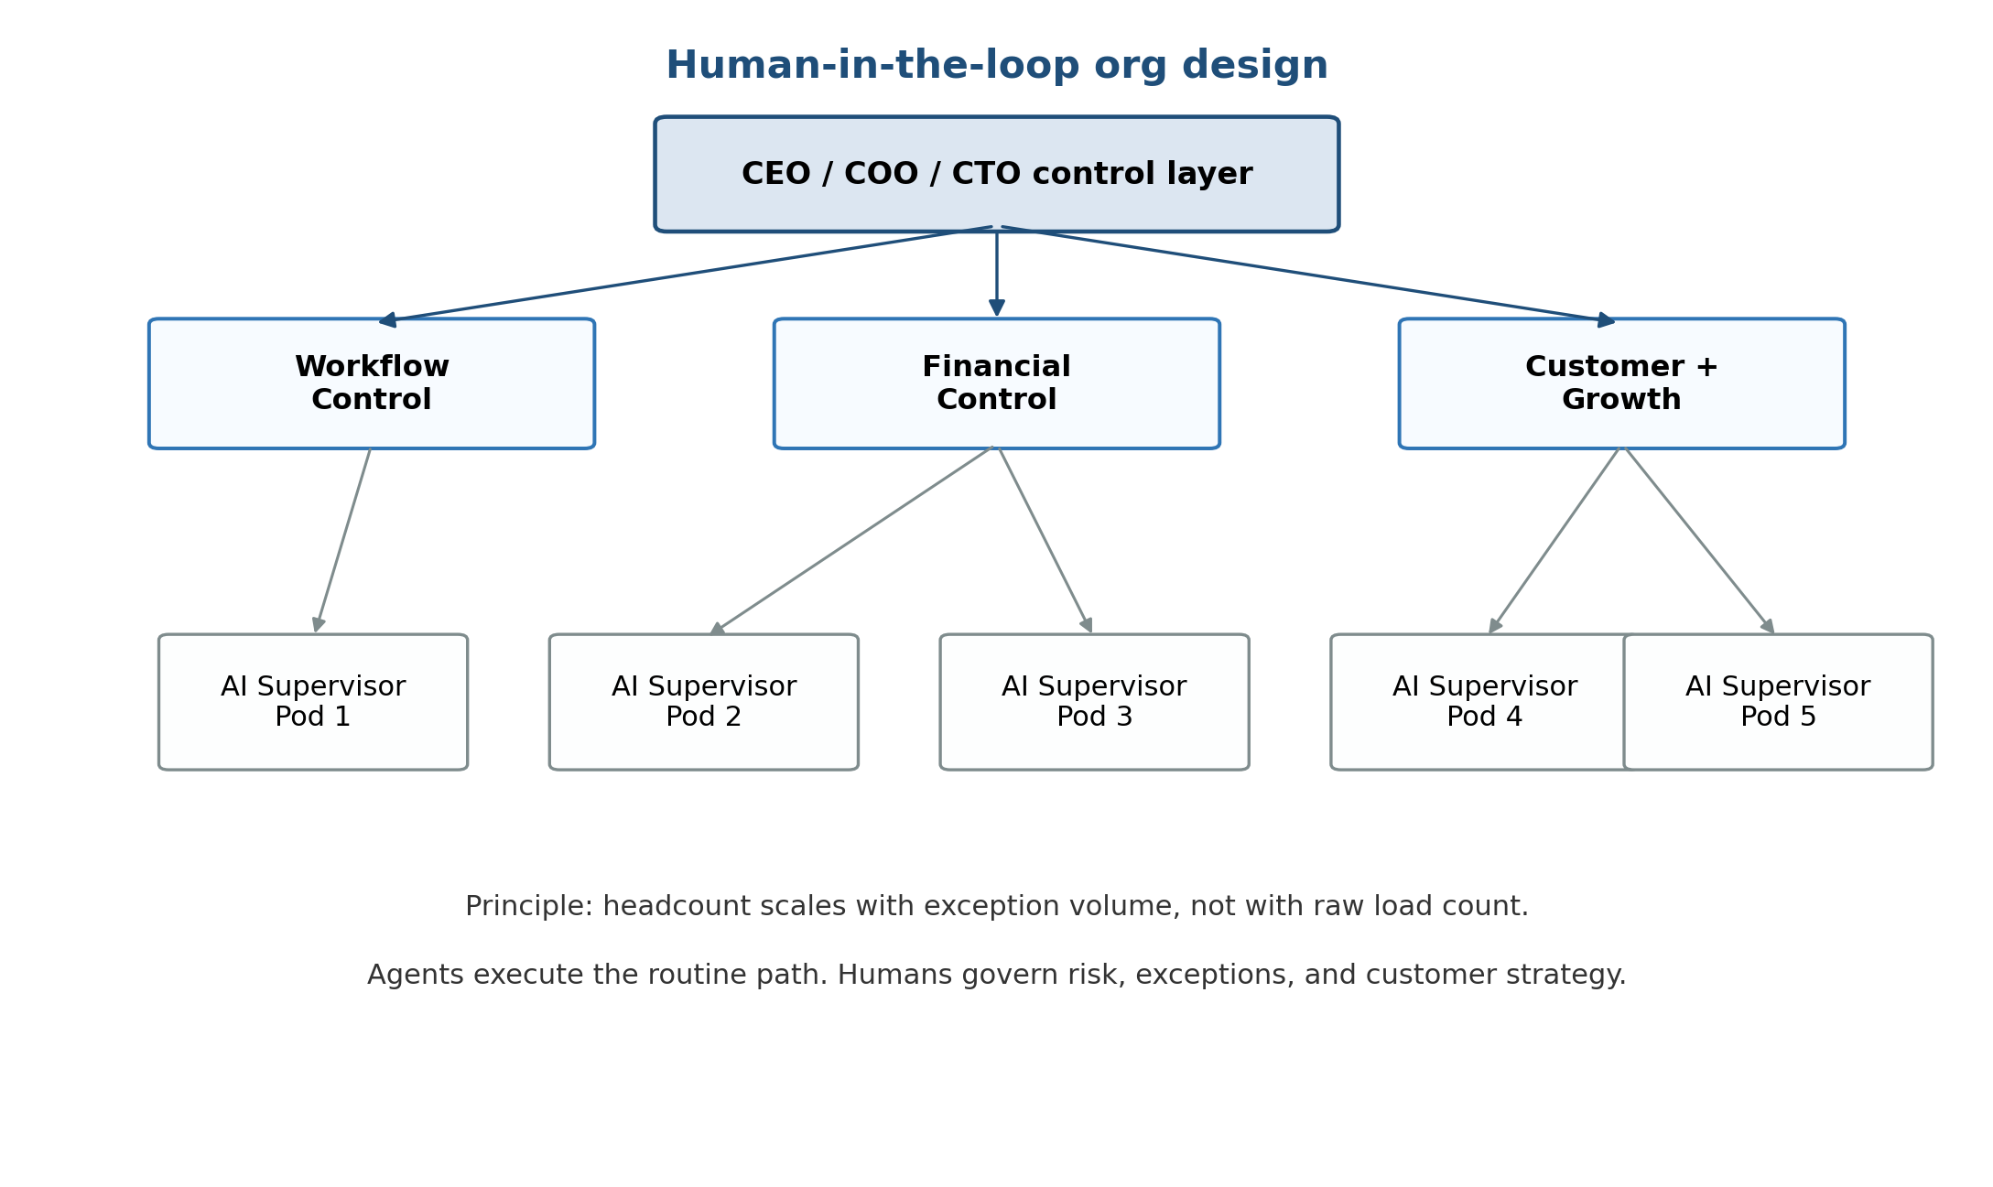
Figure 2. Reference architecture and control planes.

Architecture Layers
Executive control plane. Global orchestration, margin governance, and trust.
Compliance control plane. Driver, carrier, shipment, and customs compliance enforcement across every lifecycle stage. Hard gates block non-compliant transitions; soft gates flag for HITL review. See Section 17.
Event fabric + workflow engine. State transitions, retries, timers, escalation rules, idempotency, and audit logs.
Domain agent systems. Quoting, procurement, execution, document handling, billing, disputes, and settlement.
Integration plane. Sylectus TMS API, DAT rate/sourcing APIs, EDI, telephony, GPS / ELD, email, document ingestion, and RPA fallbacks for additional TMS targets.

Suggested Service Boundaries
Service | Primary Objects | Main Events | Why Separate
Quoting | RFQ, Quote, Customer SOP | RFQ_RECEIVED, QUOTE_SENT | High-velocity ingress; distinct pricing logic
Procurement | Load, Carrier offer, Rate conf | LOAD_CREATED, CARRIER_ASSIGNED | Requires negotiation and coverage logic
Execution | Milestones, ETA, exception | STATUS_UPDATED, DELIVERY_CONFIRMED | Continuous event ingestion and recovery rules
Documents | BOL, POD, receipts, evidence | DOC_RECEIVED, DOC_VALIDATED | Evidence extraction and validation
Financials | Charge, Invoice, Settlement, Dispute | BILL_READY, INVOICE_ISSUED, SETTLEMENT_APPROVED | Highest correctness requirements

4. State Machines and Control Logic
The system should be implemented as explicit state machines. Implicit state is the fastest route to operational ambiguity, hidden rework, and margin leakage.

Minimal State Model
Object | Core States | Gate to Next | Typical Exception | Human Intervention
RFQ | Received → Parsed → Priced → Sent → Won/Lost | Structured data + price confidence | Missing fields, ambiguous lane | Quote approval/override
Load | Created → Covered → Dispatched → In Transit → Delivered | Carrier commitment + milestones | Coverage failure, service risk | Procurement/recovery
Documents | Missing → Received → Parsed → Validated | POD/BOL consistency | Signature/receiver mismatch | Document review
Billing | Pending → Eligible → Issued → Accepted → Paid | Execution + evidence complete | Missing docs, wrong refs, dispute | Financial controller
Settlement | Pending → Matched → Approved → Paid | Three-way match + payee verify | Duplicate bill, short-pay | Settlement approval

5. Agent Hierarchy and Responsibilities
The agent fleet is not organized like a generic assistant system. It is organized by control function and lifecycle responsibility.
Executive agents: Global Orchestrator, Profit & Risk Governor, Compliance & Trust.
Lifecycle agents: Intake, Pricing, Award Detection, Load Builder, Carrier Selection, Negotiation, Tracking, Recovery, Document Understanding, Validation, Billing, Settlement, and Dispute.
Compliance agents: Driver Compliance, Carrier Compliance, Shipment Compliance, Customs Clearance, and Compliance Orchestrator.
Cross-cutting agents: Memory, Learning and Optimization, Escalation, and Tool Execution.
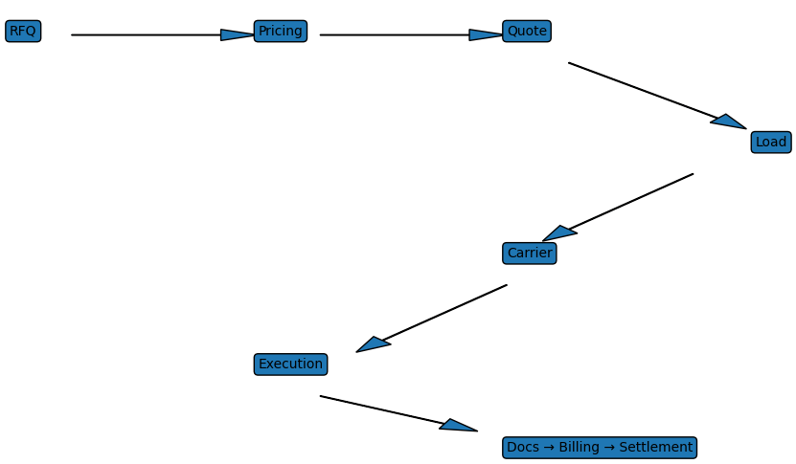
Figure 3. Agent interaction graph showing control flow between agent tiers.

Agent Design Rules
- Agents should own decision boundaries, not broad departments.
- Financial decisions should prefer deterministic rules with AI assistance, not pure generative autonomy.
- Every agent action must emit a structured event with confidence, provenance, and an idempotency key.
V5 addition: New agents for V5: Rate Audit Agent, Invoice Agent, Payment Match Agent, Settlement Agent, Dispute Agent. See Section 12 for their responsibilities and HITL gates.
V5.1 addition: Five new compliance agents form a dedicated Compliance Control Plane that intercepts every lifecycle stage. See Section 17 for the compliance infrastructure layer and Section 18 for the cross-border customs lifecycle.

6. Human-in-the-Loop Operating Model
The goal is not to remove humans from the company. The goal is to move humans up the stack: away from repetitive execution and toward supervision, exception resolution, risk control, and customer strategy.
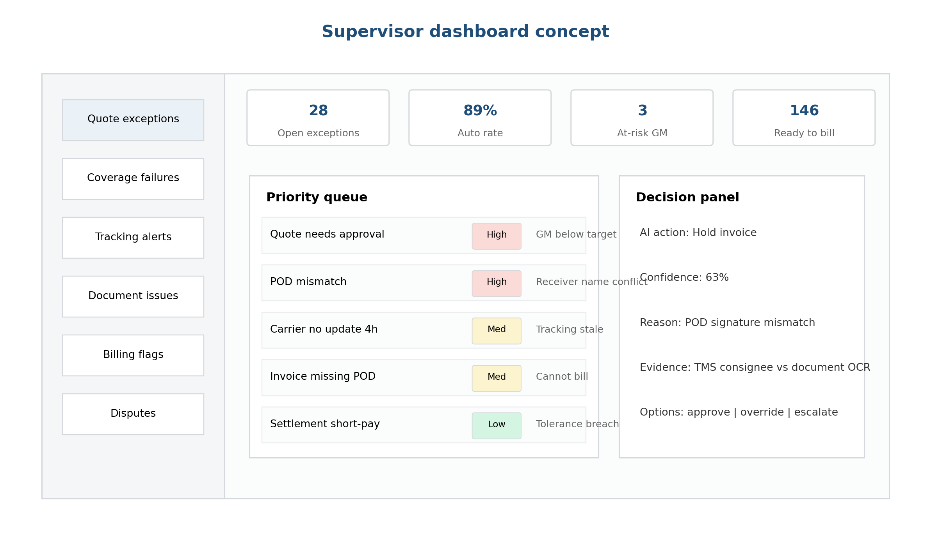
Figure 4. Human org design in an exception-driven operating model.

New Human Roles
Role | Primary Mission | Key Metrics | When Critical
AI Supervisor | Resolve priority exceptions and approve risky actions | Resolution time, re-open rate, automation rate | Immediately
Workflow Controller | Monitor stuck states and tune operational rules | Stuck-load rate, queue aging, no-silent-failure | After quoting and tracking live
Financial Controller | Protect margin and billing correctness | Billing accuracy, dispute cycle time, margin variance | When documents and billing scale
Customer Strategist | Own account quality, SOP fidelity, and growth | Win rate, renewal, SOP exception rate | As paying customers diversify

V5 Enhancement: Autonomy Graduation Framework
The V4 blueprint defined four autonomy levels but did not specify how features graduate between them. The V5 adds explicit graduation criteria, A/B testing protocols, and customer-configurable autonomy settings.
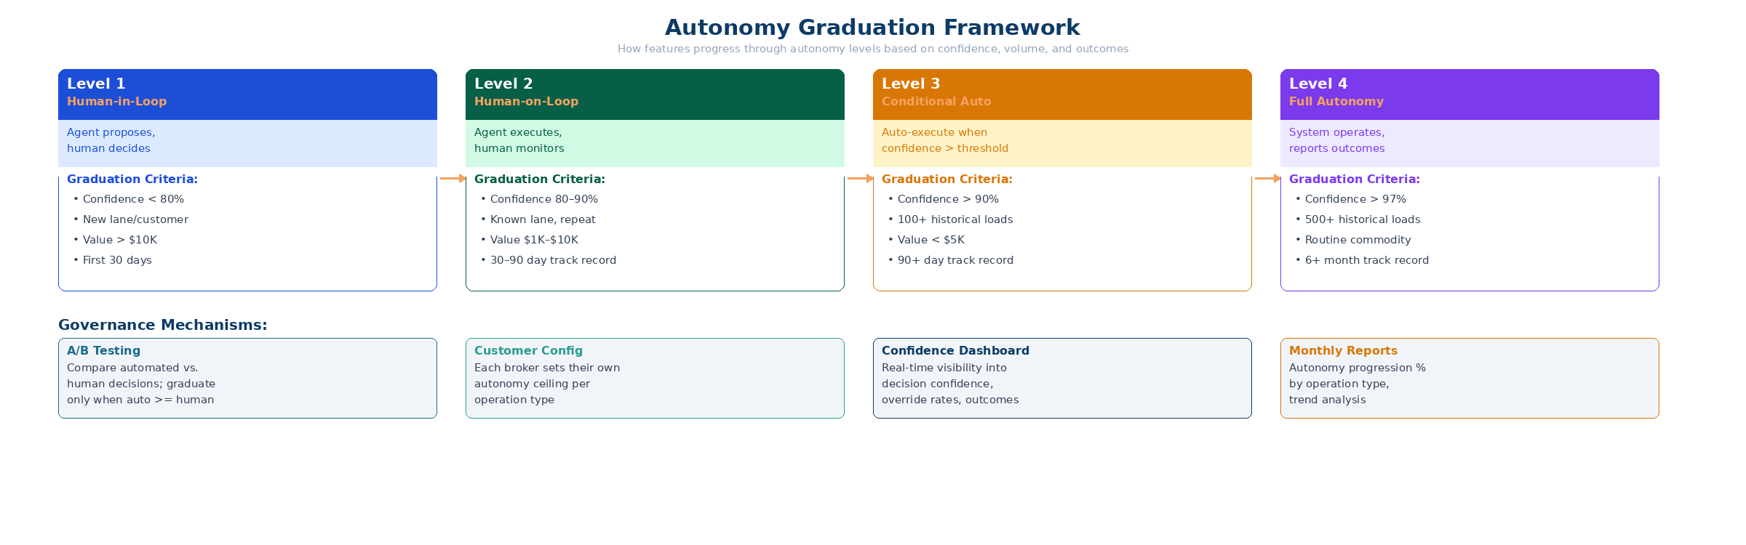
Figure 5. Autonomy graduation framework with criteria for level progression.
Each operation type (quoting, dispatch, tracking, invoicing) progresses through autonomy levels independently. A broker might have quoting at Level 3 (conditional autonomy) while invoicing remains at Level 1 (human-in-loop). Graduation is driven by:
- Confidence threshold: the system’s statistical confidence in its decision accuracy
- Volume threshold: minimum historical load count to establish baseline performance
- Outcome validation: A/B comparison showing automated decisions match or exceed human decisions
- Customer consent: each broker sets their own autonomy ceiling per operation type
Monthly autonomy reports track the percentage of decisions at each level, the trend over time, and the economic impact (time saved, margin improvement, error rate reduction).

7. Supervisor UX Surfaces
A strong human-in-the-loop model requires purpose-built interfaces. The supervisor dashboard is not a CRM, a TMS, or a shared inbox. It is an exception-resolution operating surface.
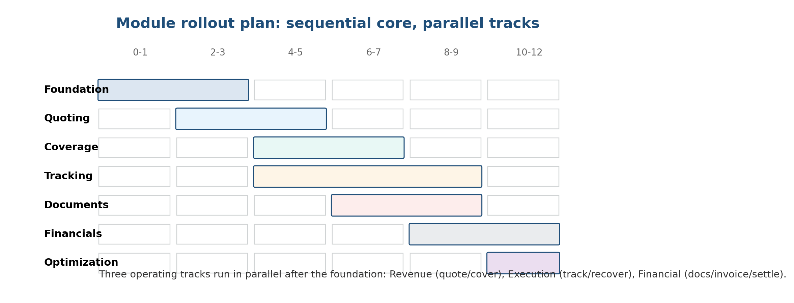
Figure 6. Dashboard concept for exception-driven supervision.

UX Principles
- Queues should be ordered by business risk, not by arrival time alone.
- Every queue item should show the AI action, confidence, evidence used, and the recommended next move.
- The default path should be one-click approve, override, or escalate; supervisors should not need to reconstruct context from multiple systems.
V5 addition: The supervisor UX now includes financial dashboards (margin analysis, carrier scorecards, customer profitability, lane performance) and an autonomy management console where brokers configure their comfort level per operation type.

8. Rollout Strategy
V5 Enhancement: Parallel-Track Architecture with Revenue Milestone Gates
V4 defined sequential phases. V5 restructures the rollout as a parallel-track model where foundation infrastructure (Track A) and commercial product (Track B) run simultaneously from Month 1. This avoids the common startup trap of spending 6–12 months on infrastructure before generating any revenue signal.
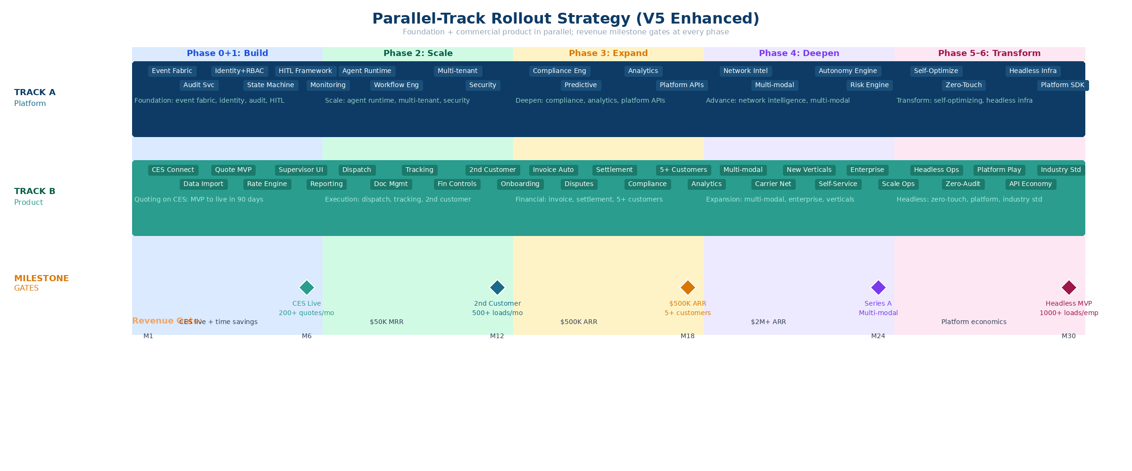
Figure 7. Parallel-track rollout strategy across 30 months with revenue milestone gates.

Enhanced Phase Definitions
Phase | Track A: Platform | Track B: Product | Revenue Gate | Timeline
0+1 Build | Event fabric, identity, audit, HITL, state machine, monitoring | CES integration, quote engine MVP, supervisor UI, quote-to-book, reporting | CES live + measurable time savings | M1–M6
2 Scale | Agent runtime, multi-tenant, workflow engine, security hardening | Dispatch, tracking, doc mgmt, financial controls, 2nd customer | $50K MRR + 2nd paying customer | M7–M12
3 Expand | Compliance engine, analytics platform, autonomy scoring, platform APIs | Invoice automation, settlement, disputes, 5+ customers | $500K ARR trajectory | M13–M18
4 Deepen | Network intelligence, multi-modal support, risk engine | New verticals, enterprise customers, self-service config | $2M+ ARR | M19–M24
5–6 Transform | Self-optimizing systems, headless infrastructure, platform SDK | Headless operations, zero-audit mode, API economy, industry standard | Platform economics | M25–M30+

Critical Rollout Principle
• Phase 0 never exists as a standalone phase. Foundation runs as Track A in parallel with commercial product.
• No phase transition without a revenue milestone gate. Technical completeness alone is insufficient.
• Financial controls are a cross-cutting concern woven into every phase, not deferred to Phase 5.
• CES is a formalized design partner with weekly feedback cycles and co-owned roadmap for Phases 1–2.

9. Economics and Scaling Model
The core economic advantage of this model is that operating expense should scale with exception density and customer complexity rather than linearly with shipment count.

Illustrative Operating Economics
Load Scale | Automation | Human Team | Loads/Employee | Interpretation
~1,000/month | 70–80% | 6–8 people | 125–170 | Prove the model and train supervisors
~5,000/month | 80–90% | 15–20 people | 250–330 | Exception-centric operations become real
~10,000+/month | 90%+ routine | 25–35 people | 300–500 | Company begins to behave like software, not labor
~50,000+/month | 95%+ | 50–70 people | 700–1,000+ | Headless platform: near-zero marginal cost per load

Economic Levers That Matter Most
- Response speed drives quote conversion upstream.
- Coverage quality and recovery speed protect service and customer trust in the middle.
- Document accuracy and financial controls protect DSO, dispute rate, and true gross margin downstream.
V5 Enhancement: Burn Model Integration
The economics model now ties directly to the seed funding milestones. At $3M seed with an 18-month runway, the company must reach Phase 2 completion and demonstrate unit economics validation ($3.08–$9.08 cost per load) before raising Series A. The 50,000+ load row represents the headless platform economics that define the Phase 6 north star.

Event-Based Cost Model
Cost Component | Core Tier | Professional Tier | Enterprise Tier
Compute (agents + inference) | $0.80/load | $1.50/load | $2.20/load
Integration (TMS + carrier APIs) | $0.60/load | $1.20/load | $1.80/load
Storage + audit | $0.30/load | $0.50/load | $0.80/load
Support + HITL overhead | $1.38/load | $3.30/load | $4.28/load
Total cost per load | $3.08/load | $6.50/load | $9.08/load
Target gross margin | 69% | 71% | 72%

10. Risks and Design Guardrails
V5 Enhancement: Expanded to include commercial and operational risks alongside architectural risks.
Risk | Severity | Why It Matters | Guardrail
Monolithic super-agent design | High | Hard to debug, govern, or trust | Keep agents narrow and event-driven
Implicit states | High | Creates ambiguity and hidden rework | Formalize lifecycle states and gates
Financial over-automation | High | Can create silent margin or payables damage | Deterministic policy checks + approval thresholds
Weak supervisor UX | Medium | Humans lose confidence and duplicate work | Queue-first review surfaces with evidence
Connector sprawl | Medium | Integration maintenance overwhelms team | Canonical models + reusable connectors
CES concentration risk | High | Single customer dependency for all validation | Second customer by M9; multi-tenancy from day one
TMS integration complexity | High | Each TMS has unique quirks; connectors slow | RPA fallback; prioritize top 5 TMS only
Scope creep toward Phase 6 | Medium | Team builds headless prematurely, neglects revenue | Revenue milestone gates at every phase
Competitive response | Low–Med | Tai/Parade add autonomous features | Speed: governed autonomy = 18+ mo moat
Operator resistance to autonomy | Medium | Operators distrust AI, revert to manual | HITL default; opt-in autonomy; show the data
Compliance data staleness | High | Expired insurance dispatched; FMCSA penalties | Continuous refresh; hard gates block non-compliant transitions
Cross-border customs delays | Medium | Held shipments, duty miscalculation, denied party exposure | Pre-filing, denied party screening, FTA optimization

11. End-State Operating Picture
In the finished model, the company behaves like a software-defined freight operator. Agents handle the routine path across quoting, coverage, execution, documents, and financial close. Humans spend most of their time on exception resolution, strategic customers, and economic governance. Investors should see a company whose margin structure improves with scale. Engineers should see a system with clear service boundaries, explicit states, and tight auditability. Operators should see a business that becomes more controllable as volume rises, not less.
V5 addition: In the ultimate end state (Phase 6), the platform operates as a headless freight nervous system. Zero-touch execution for routine freight. Self-optimizing carrier networks. Human involvement only at the strategic level: account relationships, market positioning, and economic governance. The platform can be integrated into any logistics workflow, enabling a new class of freight businesses that operate at software-like margins with freight-scale revenue.

12. Invoice-to-Cash Lifecycle
NEW IN V5 This section addresses the most significant gap in V4: the financial lifecycle from delivery confirmation to cash realization.
The V4 blueprint covered RFQ through delivery but stopped before the money moved. In freight brokerage, the invoice-to-cash cycle is where margin leakage, disputes, and cash flow problems live. This section formalizes the complete financial lifecycle as a first-class system component.
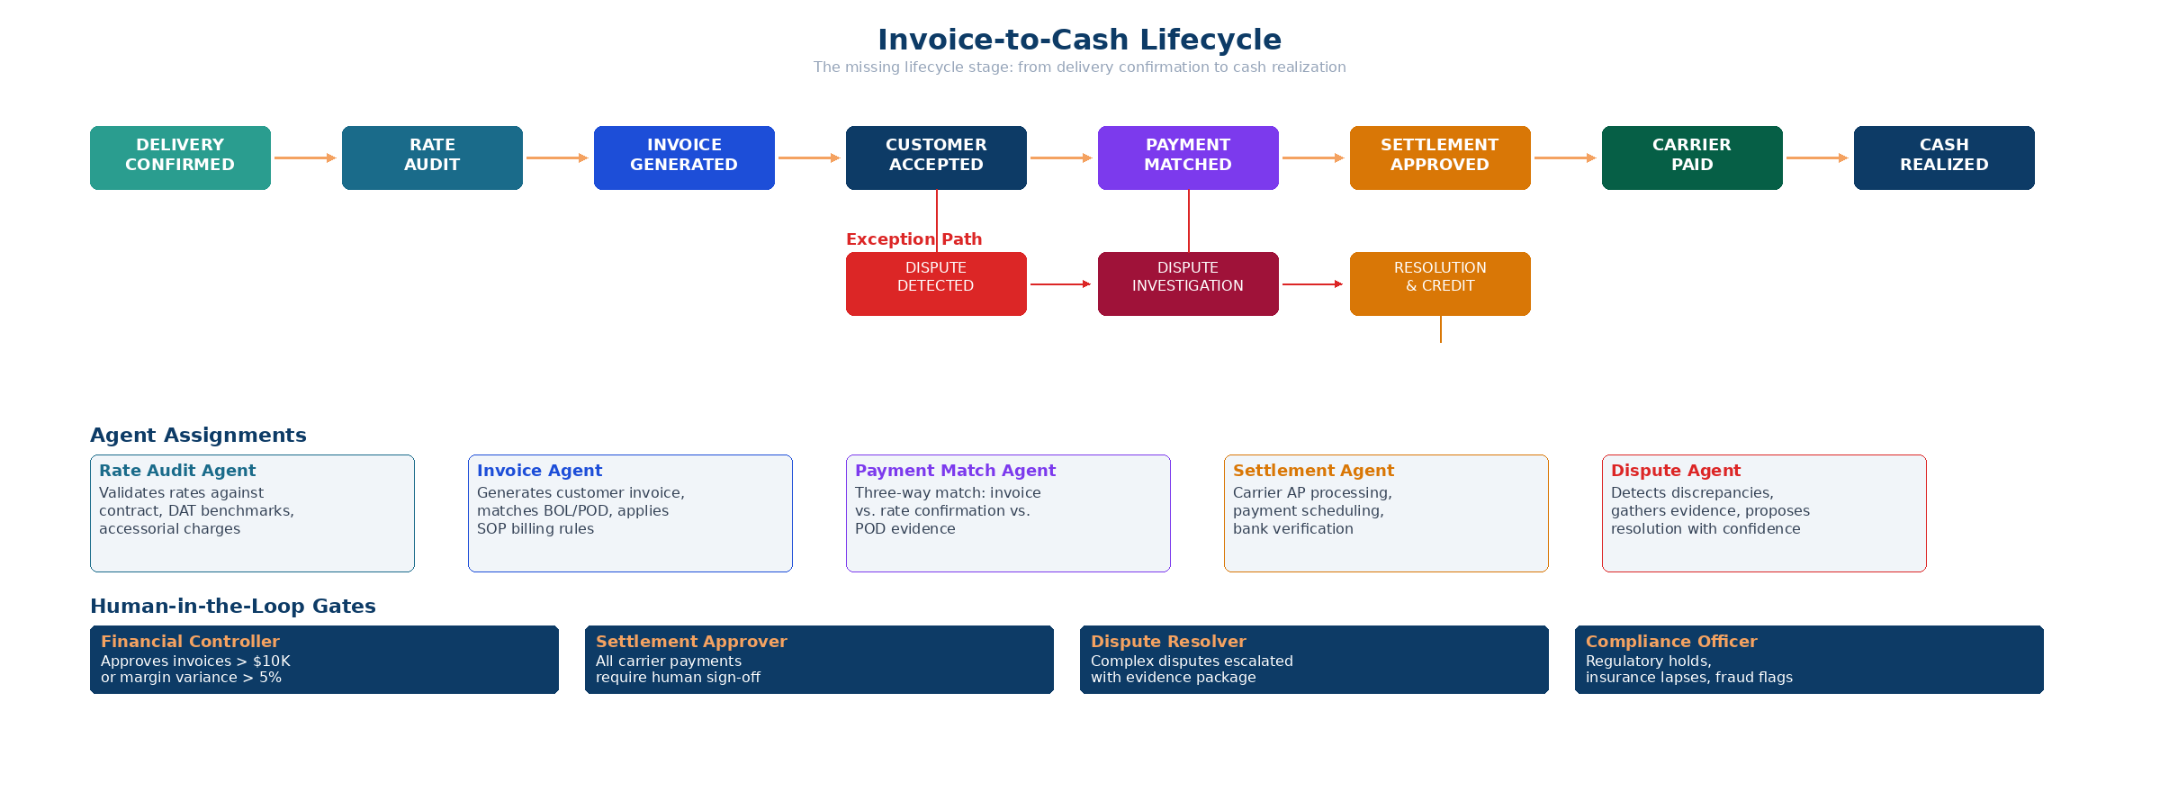
Figure 8. Complete invoice-to-cash lifecycle with agent assignments and HITL gates.

Financial State Machine
State | Trigger | Agent Action | Exception | HITL Gate
Delivery Confirmed | POD validated + milestones complete | Rate Audit Agent: validate rates vs contract | Accessorial discrepancy | Margin variance > 5%
Rate Audited | Audit pass or human override | Invoice Agent: generate customer invoice | Missing BOL/POD | Invoice > $10K
Invoice Issued | Customer receives invoice | Monitor for acceptance/dispute within SLA | Customer dispute filed | Dispute detection
Payment Matched | Customer payment received | Payment Match Agent: three-way match | Short pay, duplicate | Match failure
Settlement Approved | AR matched + AP calculated | Settlement Agent: carrier payment queue | Bank change, payee error | All settlements
Cash Realized | Carrier paid + books reconciled | Close shipment lifecycle; update P&L | Reconciliation gap | Period close

Dispute Resolution Lifecycle
Disputes are not exceptions to be handled ad hoc. They are a formal lifecycle stage with their own state machine:
- Dispute Detection: AI flags discrepancies between invoice, rate confirmation, and POD evidence
- Investigation: Dispute Agent gathers evidence, compares against SOP, rates confidence in each party’s position
- Resolution: proposes credit, adjustment, or escalation with confidence score and supporting evidence
- Credit/Adjustment: Financial Controller approves; system applies credit and updates settlement

Design Rules for Financial Automation
- Three-way match is mandatory before any payment: invoice vs. rate confirmation vs. POD evidence
- All financial agent decisions require deterministic policy checks before AI-assisted optimization
- Carrier payments always require human sign-off regardless of autonomy level (Phase 1–4)
- Dispute resolution confidence must exceed 90% before auto-resolution is even proposed
- Complete audit trail from delivery confirmation to cash realization is immutable and compliance-grade

13. Headless Brokerage: The North Star
NEW IN V5 This section articulates the ultimate vision that every phase builds toward.
The headless brokerage is a fully autonomous freight operating platform that can be integrated into any logistics workflow. It is the zero-audit logistics nervous system. No competitor is targeting this endgame, which creates the most compelling long-term moat.
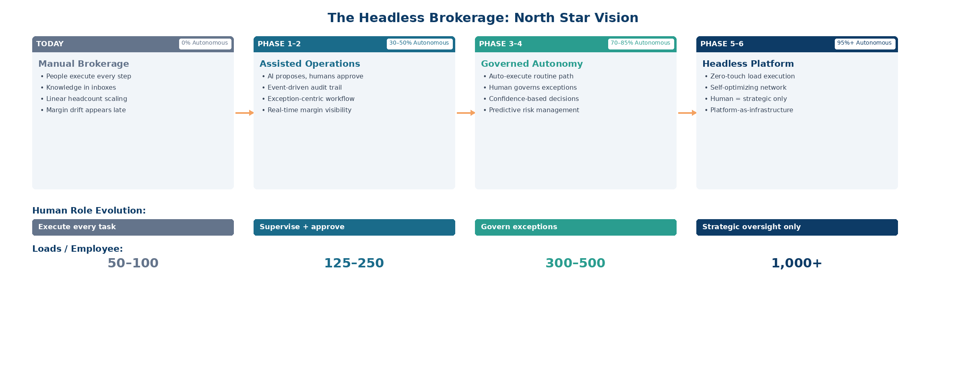
Figure 9. Evolution from manual brokerage to headless platform across all phases.

What Headless Means
- Zero-touch load execution: routine freight flows from RFQ to cash without human intervention
- Self-optimizing network: carrier relationships, lane pricing, and capacity management improve autonomously
- Human = strategic only: people focus on account relationships, market positioning, and economic governance
- Platform-as-infrastructure: other businesses can build on top of the autonomous operating layer

Why This Matters for Investors
The headless brokerage answers three critical investor questions:
- Why now? The convergence of LLM capability, TMS API availability, and broker willingness to adopt automation creates a window to build the autonomous operating system before incumbents react.
- What’s the moat? Governed autonomy is an architectural advantage that cannot be retrofitted. Competitors optimizing individual steps cannot match a system that governs the entire lifecycle.
- What’s the TAM at scale? A headless freight platform serves not just brokers but any company that moves freight: 3PLs, shippers with private fleets, carriers expanding into brokerage. The TAM expands from freight brokerage ($250B) to freight operations ($800B+).

Feasibility Timeline
Headless operation is not a single release. It is a progressive capability that deepens over time:
- Phase 1–2 (M1–12): Human-in-the-loop on all decisions; system proves accuracy
- Phase 3 (M13–18): Conditional autonomy on routine operations; human governs exceptions
- Phase 4 (M19–24): Autonomous execution on 80%+ of operations; human monitors outcomes
- Phase 5–6 (M25+): Headless mode available for qualifying brokers; human involvement optional

14. Customer Onboarding and TMS Integration
NEW IN V5 This section fills the gap between overlay architecture concept and actual customer connectivity.
The overlay architecture is well-defined conceptually, but V4 did not address how a new broker actually gets from signed contract to live operations. This is the single biggest friction point for a platform sale and must be productized.
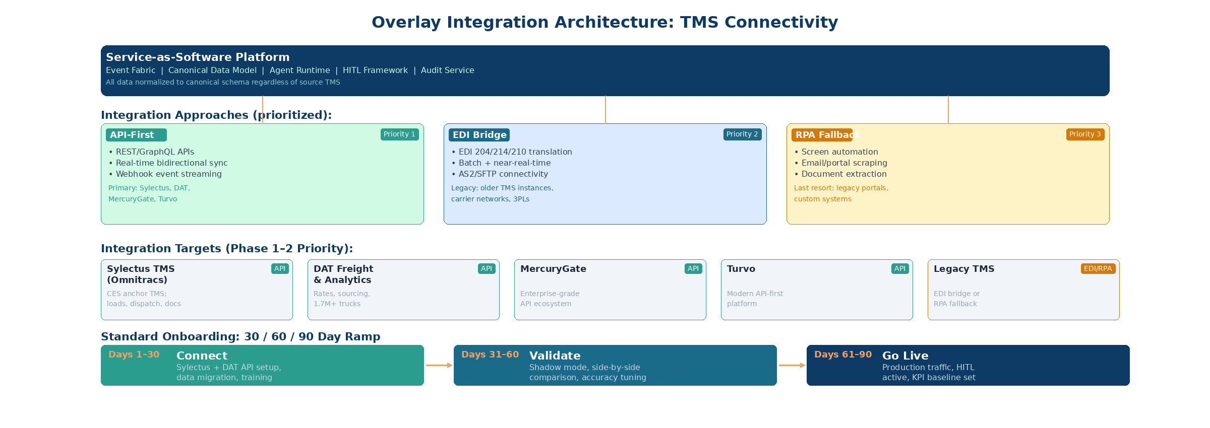
Figure 10. Overlay integration architecture showing connectivity approaches and target platforms.

Primary Integration Targets
The initial integration strategy focuses on two platforms that together cover the core TMS and sourcing needs:
Sylectus TMS (Omnitracs) — Primary TMS Integration. Sylectus is CES’s operational TMS and the anchor integration. It is a cloud-based platform with API availability for load management, dispatch, tracking, document storage, and invoicing. Sylectus integrates with accounting systems (QuickBooks, Sage, Dynamics GP), telematics providers (Samsara), and compliance tools. The overlay connects to Sylectus via API-first for bidirectional load data sync, dispatch commands, milestone/tracking events, document exchange, and invoice generation.
DAT Freight & Analytics — Sourcing and Rate Intelligence. DAT provides the pricing and carrier sourcing layer that feeds the Quoting and Carrier Selection agents. The DAT API suite covers load board posting and search, spot and contract rate benchmarking, historical lane analytics, carrier sourcing across 1.7M+ trucks, and freight tracking. DAT’s developer portal provides well-documented REST APIs. The platform uses DAT for real-time market rate benchmarks during quoting, carrier capacity search during procurement, and lane-level rate intelligence for the Profit & Risk Governor.

Integration Priority Framework
Beyond Sylectus and DAT, additional TMS and data source connections follow this priority order:
- API-First (Priority 1): REST/GraphQL APIs with real-time bidirectional sync and webhook event streaming. Sylectus (anchor), DAT APIs, and future TMS targets like MercuryGate and Turvo.
- EDI Bridge (Priority 2): EDI 204/214/210 translation with batch and near-real-time processing via AS2/SFTP. Used for legacy TMS instances and carrier networks that lack modern APIs.
- RPA Fallback (Priority 3): Screen automation, email/portal scraping, and document extraction. Last resort for legacy portals and custom systems without API or EDI support.

30/60/90 Day Onboarding Playbook
Phase | Milestone | Activities | Success Criteria
Days 1–30 | Connect | Sylectus API integration, DAT API setup, data migration, historical load import, team training, SOP documentation | Data flowing from Sylectus + DAT; team trained; SOPs captured
Days 31–60 | Validate | Shadow mode (AI runs alongside human), side-by-side comparison, accuracy tuning, confidence calibration | AI accuracy > 85%; no critical errors in shadow mode
Days 61–90 | Go Live | Production traffic with HITL active, KPI baseline established, first monthly business review | Live on production loads; KPIs baselined; CSM assigned

Data Migration Pattern
- Historical load data: minimum 12 months of load history for lane intelligence and pricing model training
- Carrier profiles: active carrier list with compliance status, performance history, and payment terms
- Customer SOPs: formalized rules for each customer’s quoting, routing, and billing preferences
- Rate tables: contracted rates from Sylectus, DAT spot and contract benchmarks, lane-level analytics, and accessorial schedules
- Document templates: BOL formats, invoice templates, and reporting requirements

15. Competitive Positioning and Feature Parity
NEW IN V5 V4 did not reference competitors. This section maps the feature landscape and defines the differentiation strategy.
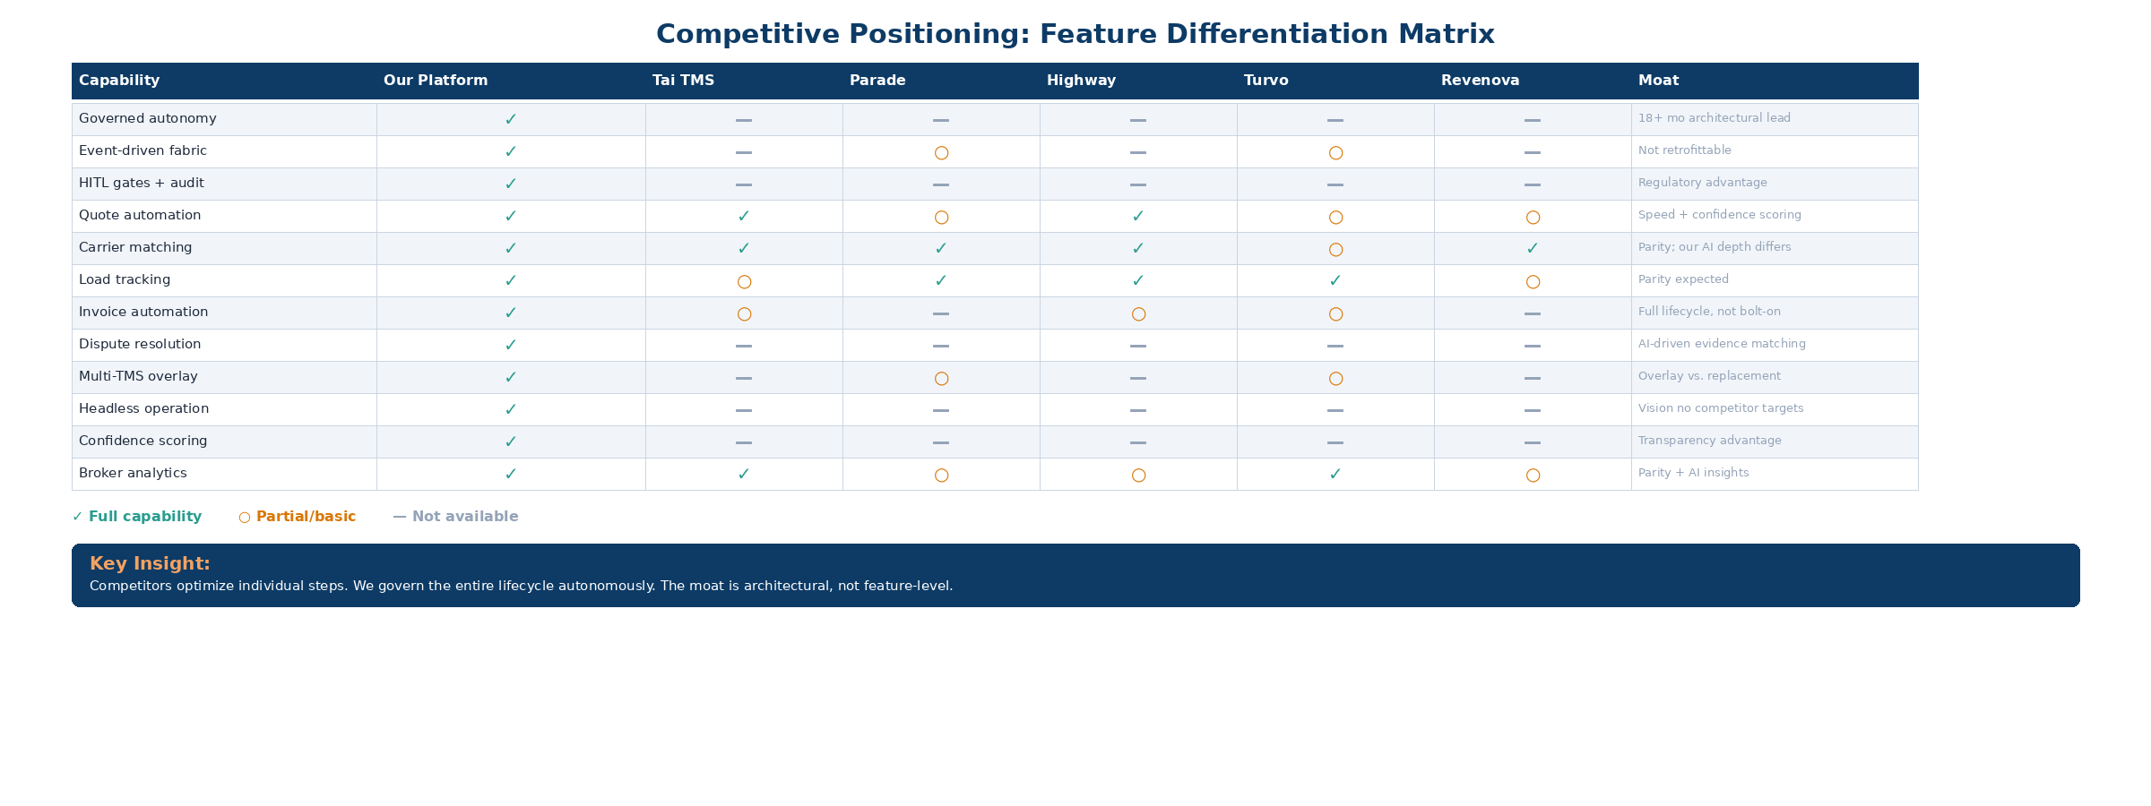
Figure 11. Competitive feature differentiation matrix across major freight-tech competitors.

Competitive Landscape
Five primary competitors are active in the freight automation space, each with a different approach:
- Tai TMS: Modern TMS replacement. Strong quoting and carrier matching but no autonomous execution or governed lifecycle management.
- Parade: Carrier network intelligence. Strong tracking and carrier matching but limited lifecycle coverage and no financial automation.
- Highway: Carrier qualification and compliance. Point solution, not a lifecycle platform.
- Turvo: Collaborative TMS with API-first architecture. Good integration story but no autonomy layer.
- Revenova: Salesforce-native freight management. CRM integration strength but limited operational automation.

Differentiation Strategy by Phase
Phase | Table Stakes (Must Match) | Our Differentiator | Positioning Message
Phase 1 | Quote automation, rate sourcing | Confidence scoring, governed approval workflow | "Not just faster quotes — trusted quotes with audit trails"
Phase 2 | Carrier matching, load tracking | Event-driven lifecycle, exception management | "Your operations run on autopilot; you handle exceptions"
Phase 3 | Basic invoicing, reporting | Full invoice-to-cash lifecycle, dispute AI | "From delivery to cash — zero leakage, zero rework"
Phase 4+ | Analytics, multi-modal | Governed autonomy, headless operation | "Your brokerage runs itself — you run the strategy"

Key Competitive Insight
• Competitors optimize individual steps. We govern the entire lifecycle autonomously.
• The moat is architectural (event fabric + governed autonomy), not feature-level.
• Competitors would need 18–24 months to retrofit their architectures — our head start.
• The overlay approach means we complement existing TMS investment, not replace it.

16. Pricing, Packaging, and Unit Economics
NEW IN V5 This section formalizes the pricing strategy that was implicit in V4’s event-cost model.
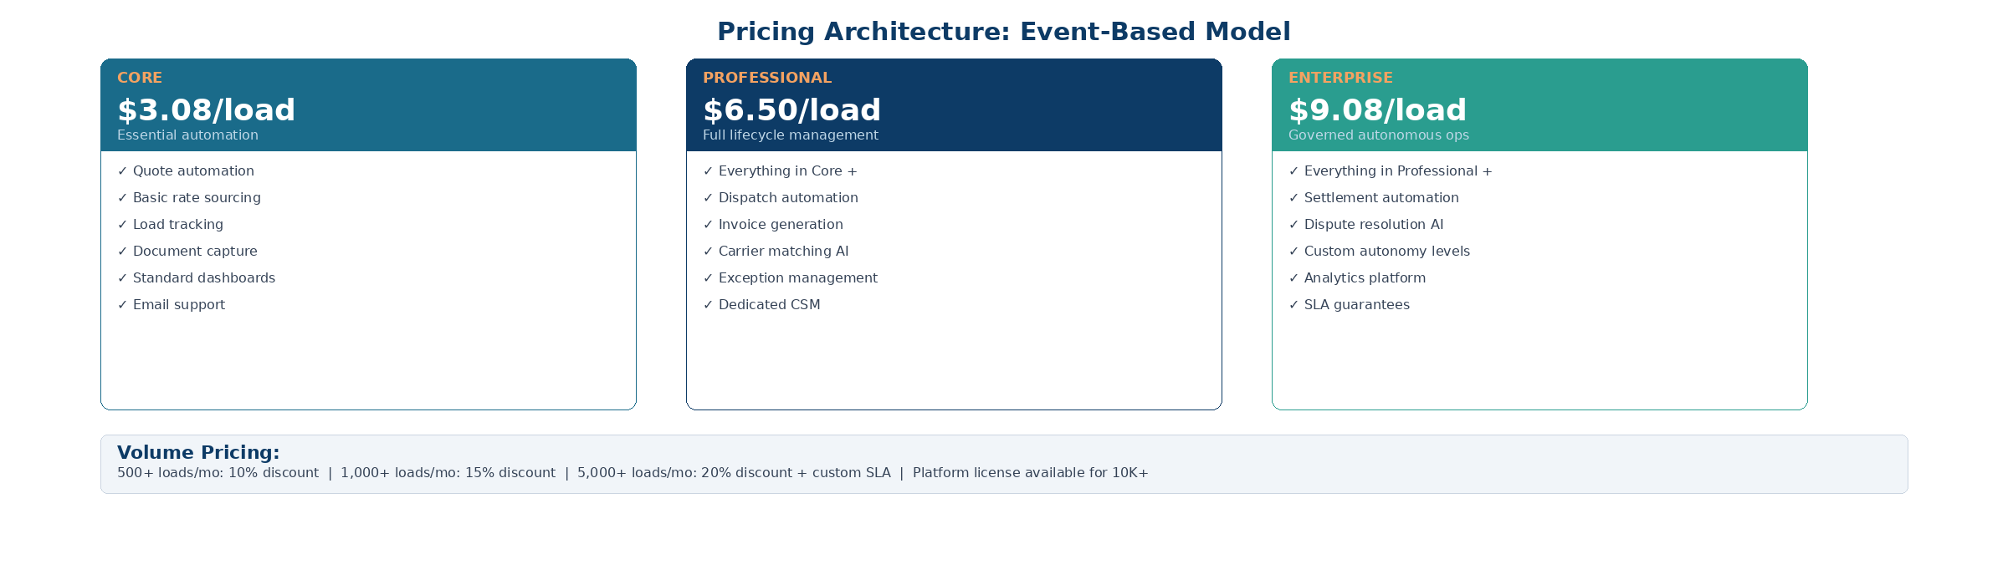
Figure 12. Three-tier pricing architecture based on event-driven cost model.

Pricing Philosophy
Pricing follows the event-driven cost model: customers pay per load processed, aligned with the value delivered. This creates natural expansion revenue as broker volume grows and ensures the platform’s cost structure scales with usage.

Tier Definitions
 | Core ($3.08/load) | Professional ($6.50/load) | Enterprise ($9.08/load)
Target customer | Small broker, 200–500 loads/mo | Mid-size broker, 500–2,000 loads/mo | Large broker, 2,000+ loads/mo
Lifecycle coverage | Quote + basic tracking | Quote through delivery + invoicing | Full RFQ-to-cash lifecycle
Autonomy level | Level 1–2 (human-in/on-loop) | Up to Level 3 (conditional auto) | Up to Level 4 (full autonomy)
Support | Email support, standard SLA | Dedicated CSM, priority support | Dedicated team, custom SLA, 24/7
Gross margin target | 69% | 71% | 72%

Volume Discounts
- 500+ loads/month: 10% discount
- 1,000+ loads/month: 15% discount
- 5,000+ loads/month: 20% discount + custom SLA
- 10,000+ loads/month: Platform license model available (annual commitment)

Revenue Expansion Model
The pricing architecture is designed for natural expansion revenue. As a broker’s volume grows and they adopt more lifecycle stages, revenue per customer increases through both volume growth and tier upgrades. A broker starting at Core (200 loads/month = $616/month) can grow to Enterprise (5,000 loads/month at 20% discount = $36,320/month) — a 59x expansion within the same account.

17. Compliance as Infrastructure
NEW IN V5 Compliance is not a feature. It is an infrastructure layer that intercepts every transaction across the entire lifecycle.
In freight brokerage, compliance failures are not edge cases. An expired carrier insurance certificate, a driver exceeding Hours of Service limits, or a missing hazmat endorsement can halt a shipment, trigger FMCSA penalties, or expose the broker to catastrophic liability. The V5 architecture treats compliance as a control plane that sits alongside the Executive Control Plane, enforcing hard gates and soft gates at every state transition.
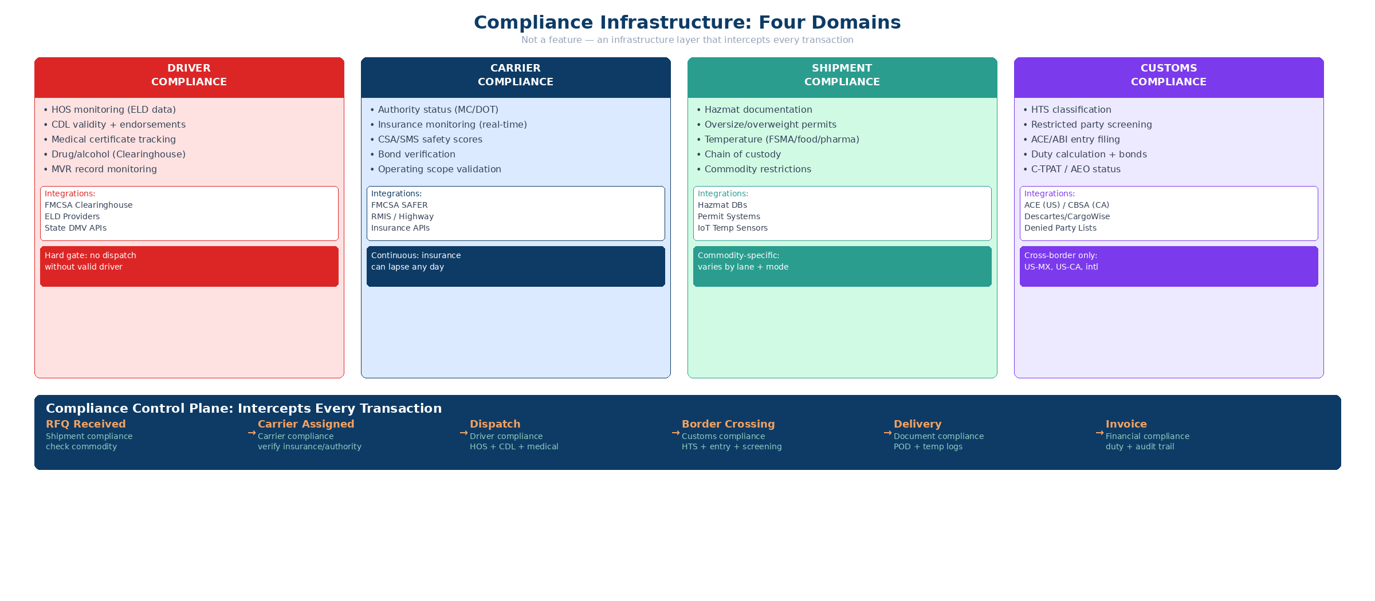
Figure 13. Four compliance domains with integrations and Compliance Control Plane flow.

Four Compliance Domains
1. Driver Compliance. Hours of Service (HOS) monitoring via ELD integration, CDL verification and endorsement tracking, medical certificate (DOT physical) expiration management, drug and alcohol testing compliance, and driver qualification file (DQF) maintenance.
2. Carrier Compliance. Insurance certificate tracking with automated expiration alerts, operating authority verification (MC/DOT), FMCSA Safety Measurement System (SMS) and CSA score monitoring, broker-carrier agreement validation, and W-9/payment credential verification.
3. Shipment Compliance. Hazmat classification and required endorsements, oversize/overweight permit requirements, temperature-controlled shipment monitoring, chain of custody documentation, and insurance coverage adequacy per commodity value.
4. Customs Compliance (Cross-Border). HTS classification and duty rate determination, denied party screening (BIS, OFAC, DDTC), ACE/ACI electronic manifest filing, customs bond management, and Free Trade Agreement certificate of origin validation. See Section 18 for the complete cross-border lifecycle.

Compliance Control Plane
The Compliance Control Plane operates as a parallel authority to the Executive Control Plane. Every lifecycle state transition passes through a compliance check before proceeding. The control plane enforces two types of gates:
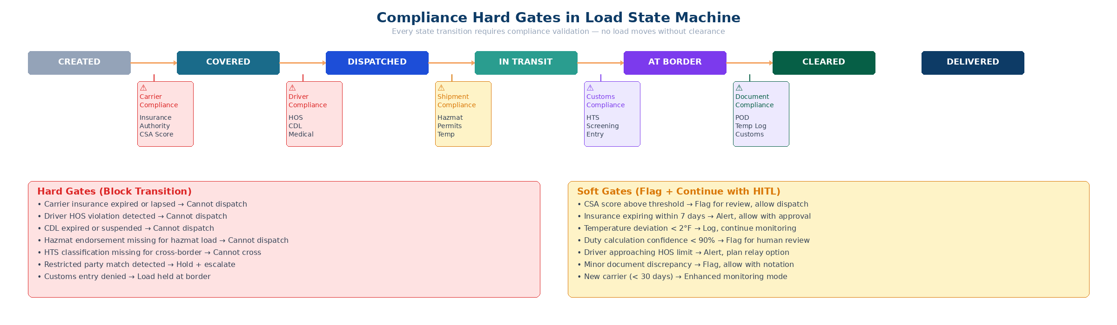
Figure 14. Load state machine with compliance hard gates and soft gates at every transition.
Hard gates block state transitions entirely. A load cannot move from Covered to Dispatched if the carrier’s insurance is expired, the assigned driver’s HOS would be violated, or required hazmat endorsements are missing. These are non-negotiable compliance failures that expose the broker to regulatory liability.
Soft gates flag the transition for HITL review but allow it to proceed with human approval. Examples include a carrier’s CSA score approaching the threshold, a driver nearing HOS limits (but not exceeding them), or insurance certificates expiring within 30 days. Soft gates surface risk without blocking operations.

Compliance Agent Fleet
Agent | Domain | Key Integrations | Gate Type
Driver Compliance Agent | HOS, CDL, medical cert, DQF | ELD providers, FMCSA SAFER, state DMV | Hard: HOS violation, expired CDL  Soft: approaching HOS limit
Carrier Compliance Agent | Insurance, authority, CSA, agreements | FMCSA SMS, insurance APIs, RMIS, Highway | Hard: expired insurance, revoked authority  Soft: CSA score trending up
Shipment Compliance Agent | Hazmat, permits, temperature, custody | PHMSA, state DOT permit systems | Hard: missing hazmat endorsement  Soft: permit expiring within 7 days
Customs Clearance Agent | HTS, screening, manifests, bonds | CBP ACE, CBSA ACI, denied party lists | Hard: denied party match, missing bond  Soft: HTS confidence < 95%
Compliance Orchestrator | Cross-domain coordination | All compliance agents + Executive CP | Aggregates results; escalates multi-domain failures to HITL

Compliance Design Principles
• Compliance is infrastructure, not a feature. It cannot be toggled off or deferred to a later phase.
• Hard gates are non-negotiable. No human override can bypass an expired insurance certificate or HOS violation.
• Soft gates respect operator judgment. They surface risk but trust the human to make the final call.
• Every compliance check is logged with timestamp, data source, confidence score, and outcome for full audit trail.
• Compliance data sources are refreshed continuously, not at load creation time only. A carrier’s insurance can expire mid-transit.

18. Cross-Border Customs Lifecycle
NEW IN V5 Cross-border shipments introduce a parallel customs lifecycle that interleaves with the canonical freight lifecycle.
For US-Canada and US-Mexico cross-border freight, the canonical RFQ-to-cash lifecycle gains an additional set of state transitions, regulatory requirements, and financial streams. This section defines how customs clearance integrates with the autonomous operating system.
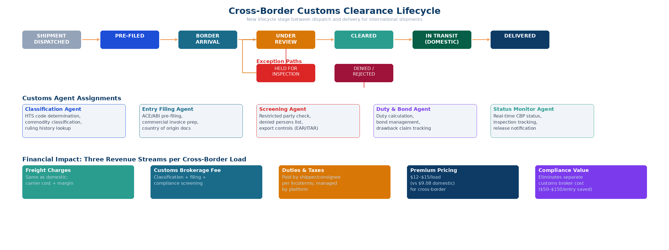
Figure 15. Cross-border customs state machine with agent assignments, exception paths, and financial streams.

Customs State Machine
State | Trigger | Agent Action | Exception | HITL Gate
Pre-Filed | Load dispatched for cross-border lane | Customs Agent: classify HTS codes, screen denied parties, file ACE/ACI manifest | HTS ambiguity, denied party flag | Denied party match; HTS confidence < 95%
Border Arrival | Truck arrives at port of entry | Monitor CBP/CBSA processing status; validate bond sufficiency | Documentation hold, random inspection | Bond insufficiency
Under Review | CBP/CBSA flags for examination | Customs Agent: prepare supplemental documentation, coordinate with broker | Classification dispute, valuation challenge | All review cases
Cleared | Customs release issued | Update load state to In Transit (domestic); trigger duty payment calculation | Conditional release with bond | Duty amount > $5K
Held / Denied | CBP/CBSA denies entry or holds indefinitely | Escalate to Compliance Orchestrator; notify customer; trigger exception recovery | Contraband, prohibited goods, sanctions | All denied/held cases

Three Financial Streams per Cross-Border Load
Cross-border shipments generate three distinct financial streams, each with its own billing, settlement, and compliance requirements:
- Stream 1 — Freight charges: Standard domestic freight charges apply to the transportation component. These follow the same invoice-to-cash lifecycle as domestic loads (Section 12).
- Stream 2 — Customs brokerage fees: Professional fees for customs classification, filing, and clearance management. Billed separately from freight charges, typically per-entry plus document fees.
- Stream 3 — Duties and taxes: Import duties, GST/HST (Canada), IVA (Mexico), and other government-imposed charges. These are pass-through costs that must be tracked, advanced, and reconciled separately from freight and brokerage revenue.

Cross-Border Pricing Impact
Cross-border loads carry a pricing premium over domestic enterprise loads due to the additional compliance, customs processing, and financial complexity:
Component | Domestic Enterprise | Cross-Border | Delta
Base platform fee | $9.08/load | $9.08/load | —
Customs processing | — | $2.00–$4.00/load | +$2.00–$4.00
Compliance overhead | Included | $1.00–$2.00/load | +$1.00–$2.00
Total per load | $9.08 | $12.08–$15.08 | +33–66%

Free Trade Agreement Optimization
A significant value-add for cross-border customers is automated FTA optimization. The Customs Clearance Agent evaluates whether goods qualify for preferential duty rates under USMCA (formerly NAFTA), and proactively generates certificates of origin when applicable. For high-volume cross-border brokers, duty savings from FTA optimization alone can exceed the platform fee.

Cross-Border Rollout Strategy
• Phase 2: Add cross-border as a lane type in the canonical lifecycle; basic HTS classification and ACE filing.
• Phase 3: Full customs lifecycle with denied party screening, bond management, and duty calculation.
• Phase 4: Automated FTA optimization, multi-corridor support (US-CA, US-MX), and customs analytics.
• Phase 5–6: Headless cross-border execution with autonomous customs clearance for qualifying lanes.

Appendix A: Implementation Checklist for V1 Build
Original V4 checklist (preserved):
- Define canonical shipment, quote, charge, invoice, and settlement identifiers.
- Stand up the event fabric and workflow engine before building agent-heavy features.
- Implement confidence scoring and escalation routes in the first shipped module, not later.
- Create a single supervisor dashboard with queue-based intervention before adding more agents.
- Instrument conversion, exception rate, queue aging, billing accuracy, and margin variance from day one.

V5 additions to checklist:
- Formalize CES design partner agreement with weekly feedback cadence and shared KPIs.
- Build rate audit as a cross-cutting service in Phase 1, not a Phase 5 feature.
- Define 30/60/90 day onboarding playbook and validate with CES before second customer.
- Establish A/B testing framework for autonomy graduation before enabling Level 2+ on any operation.
- Create competitive feature matrix and update it quarterly as market evolves.
- Build pricing calculator tool for sales team based on event-cost model.
- Define revenue milestone gates for each phase transition and enforce them.
- Document headless brokerage vision in investor materials as the explicit north star.

V5.1 compliance additions to checklist:
- Integrate carrier insurance verification API (RMIS or equivalent) in Phase 1, not Phase 3.
- Build ELD integration for real-time HOS monitoring before dispatching first load.
- Implement compliance hard gate framework in the state machine engine from day one.
- Define compliance audit trail schema: every check must log timestamp, source, confidence, and outcome.
- For cross-border customers: integrate CBP ACE portal API and denied party screening in Phase 2.
- Establish compliance data refresh cadence: carrier insurance and authority checked daily, driver HOS checked per-dispatch.

Appendix B: Visual Diagrams
System Architecture Overview:
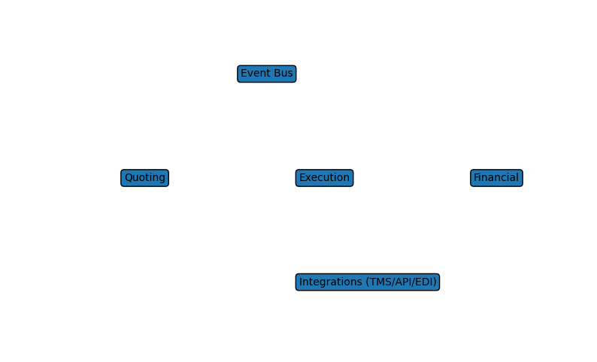
System architecture showing service boundaries and data flow.
Supervisor UX Concept:
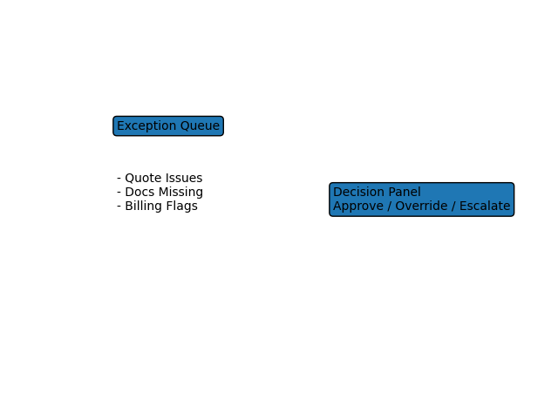
Supervisor UX dashboard concept for exception-driven operations.

Compliance Infrastructure Layer:

Four compliance domains with integrations and Compliance Control Plane.
Compliance Gates in Load State Machine:

Hard gates vs. soft gates at every lifecycle transition.
Cross-Border Customs Lifecycle:

Customs state machine with agent assignments and financial streams.

